CDDB-Ⅲ、CTDB-Ⅲ
Sami-Electric Pallet Stacker
- Operation manual
- Spare parts catalogue

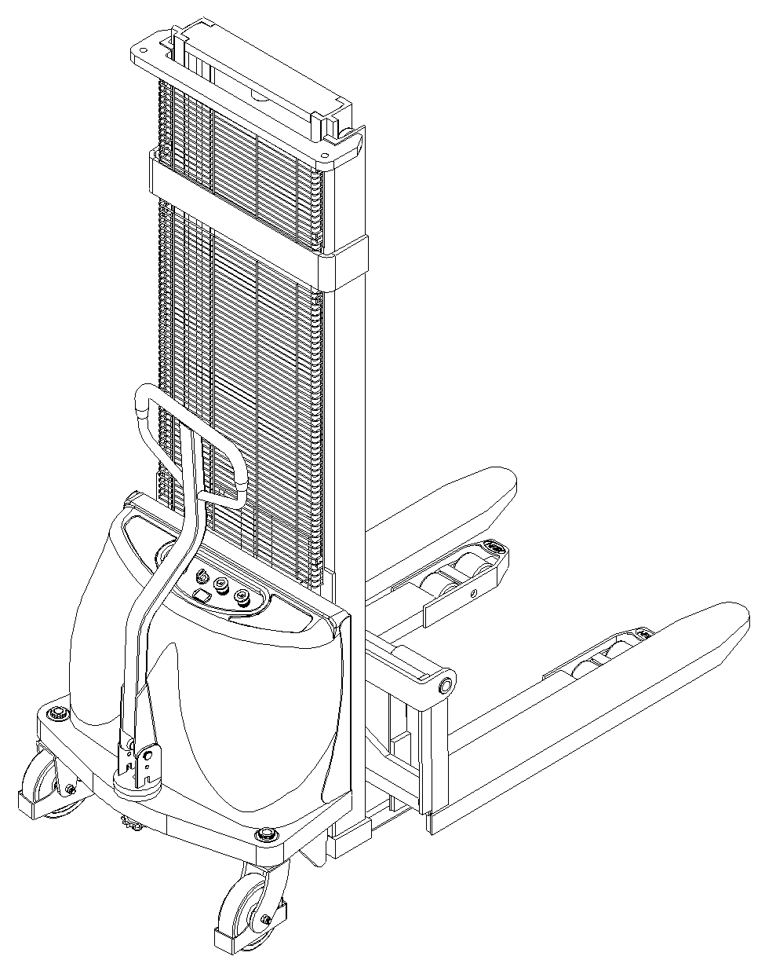

2010-06
EC Declaration of Conformity
according to the Machinery Directive 2006/42/EC
For the following equipment: :
Product : Sami- Electric Pallet Stacker
Type Designation /Trademark : CDD10B
Manufacturers Name :
Manufacturers Address :

Refer to in this declaration conforms with the following directive(s):
Machinery Directive 2006/42/EC

The company named above will keep on file for review the following technical documentation :
- Operating and maintenance instructions
- Technical drawings
- Risk assessment
- Description of measures designed to ensure conformity
- Other technical documentation ,e.g. quality assurance measures for design and production

We hope our electric stackers will bring great convenience to your work.

- Please read the manual carefully before operation.
- This manual is a common manual. We reserve the right to modify technology of the electric stacker. If there is anything in the manual that is not consistent with the actual stacker, the actual stacker should be considered correct and the manual is only for reference.
Warning
According to ISO 3691 “Safety Specification of Motor Industrial Vehicles”, Load capacity and lifting height of our CDDB-Ⅲ、CTDB-Ⅲ Electric Pallet Stacker are stipulated as follows:
- When the lifting height of CDDB-Ⅲ、CTDB-Ⅲ stacker is below 2500mm (including2500mm), the maximum load capacity is the rated capacity. Overload is prohibited.
- When the lifting height of CDDB-Ⅲ、CTDB-Ⅲ stacker is above 2500mm (excluding2500mm), the maximum load capacity is less than the rated capacity. And the detailed load capacity is stated as the following figure:
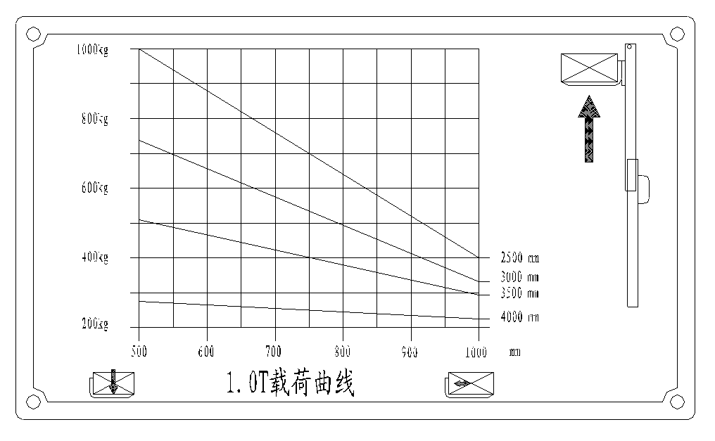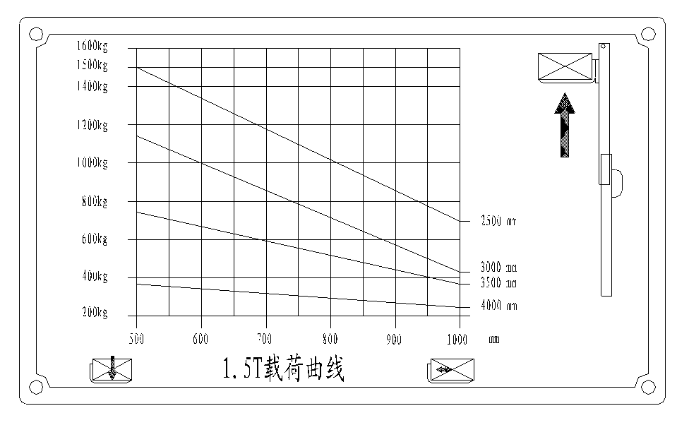
1.5T Load curve
1.0T Load curve
Note:
When the lifting height of the forks exceeds 500mm, the stacker must travel at the lowest speed and the continual travel distance must not exceed 2m. It is strictly forbidden to operate the stacker for long distance carrying when the lifting height of forks exceeds 500mm.
The truck operator must strictly conform to ISO 3691“Safety Specification of Motor Industrial Vehicles”. It is not allowed for untrained personnel to operate the stacker.
Table of Contents
1. Configuration diagram 1
2. Main technical parameters 3
3. Use and scope 5
4. Brief introduction of structure 5
5. Use and operation instruction 5
6. Maintenance and upkeep 6
7. Common fault and trouble shooting 7
8. Use, maintenance and charging of the batteries 8
9. Lists of accessories, spare parts and vulnerable parts 9
10. Package & transportation 10
11. Warning (points for attention) 10
12. Structure diagram and principle diagram of the major parts 11
13. Packing list 13

- Configuration diagram
1.1 CDDB-Ⅲ Configuration diagram
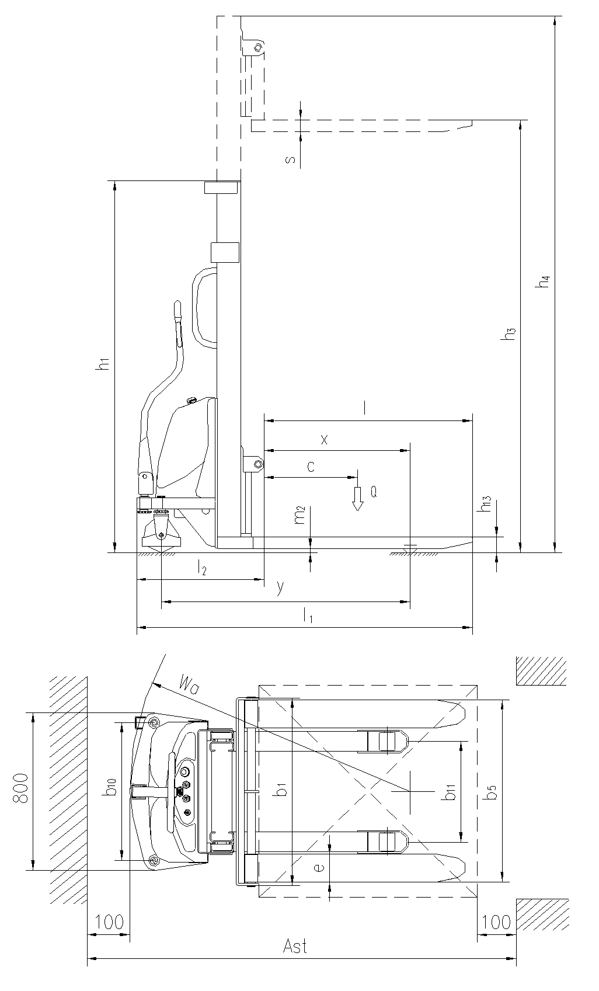
1.2 CTDB-Ⅲ Configuration diagram
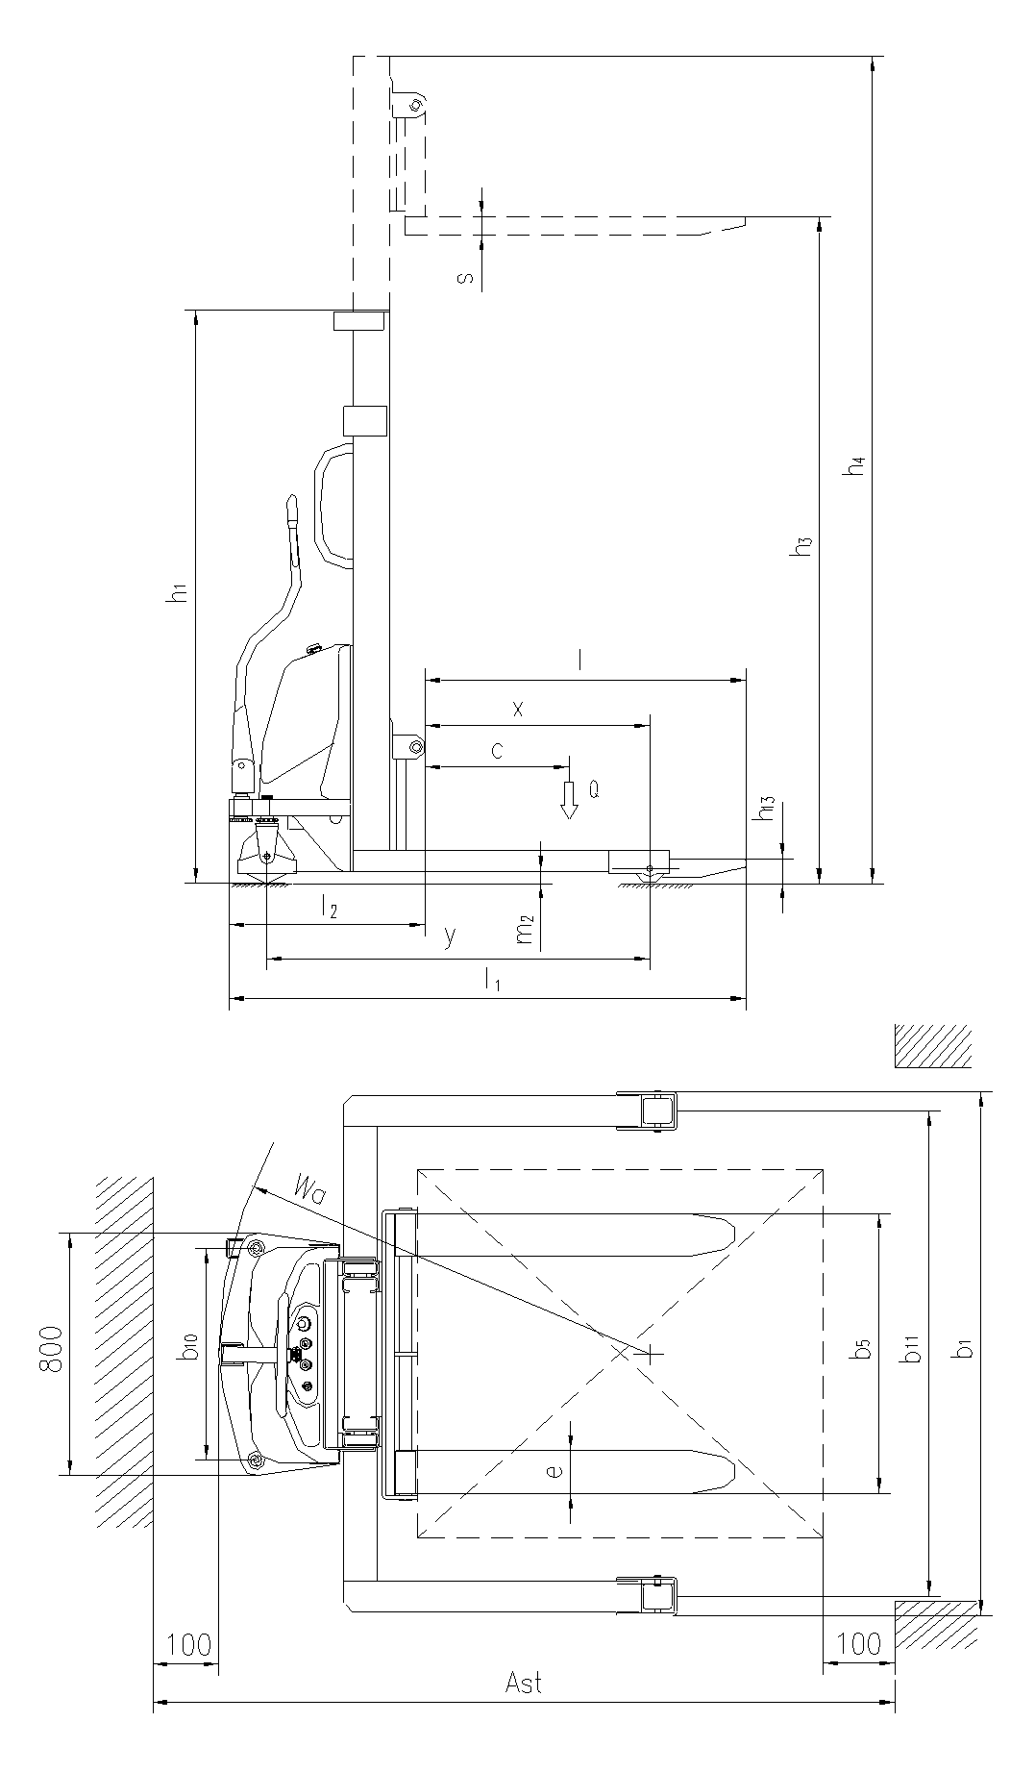

- Main technical parameters
2.1 Main technical parameters (CDDB-Ⅲ Semi-Electric Stacker)
Characteristics | 1.2 | Model |  | CDD10B-Ⅲ |  |  | CDD15B-Ⅲ
 | 1.4 | Operation mode (manual, walking, stand driving, seat driving ,order picking) |  | Manual
 | 1.5 | Rated load | Q(kg) | 1000 | 1500
 | 1.6 | Load center distance | c(mm) | 500
 | 1.8 | Front overhang | x(mm) | 654 |  |  | 636
 | 1.9 | Tread | Y(mm) | 1185 |  |  | 1265
Weight | 2.1 | Service weight (with storage battery) | kg | 385/440/475/490 |  |  | 435/510/535
 | 2.2 | Axle loading, laden front/rear | kg | 540/900 |  |  | 661/1349
 | 2.3 | Axle loading, unladen front/rear | kg | 345/95 |  |  | 385/125
Chassis | 3.1 | Wheels (rubber, high elasticity, pneumatic tyre, polyurethane wheel) |  | Nylon
 | 3.2 | Front wheel dimension |  | φ180×50
 | 3.3 | Rear wheel dimension |  | φ80×70
 | 3.5 | Wheel number, front/rear (x=driving wheel) |  | 2/2 or 4
 | 3.6 | Tread, front wheel | b₁₀(mm) | 700
 | 3.7 | Tread, rear wheel | b₁₁(mm) | 410/510
Dimension | 4.2 | Height, mast lowered | h₁(mm) | 2090/1840/2090/2240
 | 4.4 | Lifting height | h₃(mm) | 1600/2500/3000/3300
 | 4.5 | Max. height, mast extended | h₄(mm) | 2090/3060/3560/3860
 | 4.15 | Height, lowered | h₁₃(mm) | 90
 | 4.19 | Overall length | l₁(mm) | 1735 |  | 1835
 | 4.20 | Length of forks | l₂(mm) | 531 |  | 629
 | 4.21 | Overall width | b₁(mm) | 967
 | 4.22 | Fork dimension | S/e/l(mm) | 60/142/1070
 | 4.25 | Overall width of forks | b₅(mm) | 295-930
 | 4.32 | Wheelbase ground clearance | m₂(mm) | 21
 | 4.33 | Aisle width for pallets 1000x1200 crossways | A_{st}(mm) | 2315 |  |  |  | 2407
 | 4.34 | Aisle width for pallets 800x1200 lengthways | A_{st}(mm) | 2300 |  |  |  | 2396
 | 4.35 | Turning radius | W_{a}(mm) | 1425 |  |  |  | 1505
Performance Data | 5.2 | Lifting speed, laden/unladen | m/s | 0.07/0.1
 | 5.3 | Lowering speed, laden/unladen | m/s | 0.15/0.12 |  |  | 0.12/0.15
 | 5.10 | Traveling brake |  | Mechanical brake
Motor | 6.2 | Lifting motor power | kW | 1.6 |  |  |  |  | 2.0
 | 6.4 | Storage battery voltage/ rated capacity | V/Ah | 12/120 |  |  |  |  | 24/120
 | 6.5 | Storage battery weight | Kg | 45 |  |  |  |  | 90
 | 6.6 | Dimension of storage battery (L x W x H) | mm | 360×170×250
 | 8.4 | Noise level at operator’s ear, according to DIN12053 | dB(A) | ＜70
2.2 Main technical parameters (CTDB-Ⅲ Semi-Electric Stacker)
Characteristics | 1.2 | Model |  | CTD10B-Ⅲ |  |  | CTD15B-Ⅲ
 | 1.4 | Operation mode (manual, walking, stand driving, seat driving ,order picking) |  | Manual
 | 1.5 | Rated load | Q(kg) | 1000 | 1500
 | 1.6 | Load center distance | c(mm) | 500
 | 1.8 | Front overhang | x(mm) | 757 |  |  | 739
 | 1.9 | Tread | Y(mm) | 1288 |  |  | 1368
Weight | 2.1 | Service weight (with storage battery) | kg | 405/460/495 |  |  | 455/525/530
 | 2.2 | Axle loading, laden front/rear | kg | 545/915 |  |  | 675/1350
 | 2.3 | Axle loading, unladen front/rear | kg | 345/115 |  |  | 390/135
Chassis | 3.1 | Wheels (rubber, high elasticity, pneumatic tyre, polyurethane wheel) |  | Nylon
 | 3.2 | Front wheel dimension |  | φ180×50
 | 3.3 | Rear wheel dimension |  | φ98×82
 | 3.5 | Wheel number, front/rear (x=driving wheel) |  | 2/2
 | 3.6 | Tread, front wheel | b₁₀(mm) | 700
 | 3.7 | Tread, rear wheel | b₁₁(mm) | 1042-1400
Dimension | 4.2 | Height, mast lowered | h₁(mm) | 2145/1895/2145
 | 4.4 | Lifting height | h₃(mm) | 1600/2500/3000
 | 4.5 | Max. height, mast extended | h₄(mm) | 2145/3100/3600
 | 4.15 | Height, lowered | h₁₃(mm) | 80
 | 4.19 | Overall length | l₁(mm) | 1735 |  | 1835
 | 4.20 | Length of forks | l₂(mm) | 531 |  | 629
 | 4.21 | Overall width | b₁(mm) | 1167-1525
 | 4.22 | Fork dimension | S/e/l(mm) | 60/142/1070
 | 4.25 | Overall width of forks | b₅(mm) | 295-930
 | 4.32 | Wheelbase ground clearance | m₂(mm) | 40
 | 4.33 | Aisle width for pallets 1000x1200 crossways | A_{st}(mm) | 2391 |  |  |  | 2471
 | 4.34 | Aisle width for pallets 800x1200 lengthways | A_{st}(mm) | 2391 |  |  |  | 2471
 | 4.35 | Turning radius | W_{a}(mm) | 1425 |  |  |  | 1505
Performance Data | 5.2 | Lifting speed, laden/unladen | m/s | 0.07/0.1
 | 5.3 | Lowering speed, laden/unladen | m/s | 0.15/0.12 |  |  | 0.12/0.15
 | 5.10 | Traveling brake |  | Mechanical brake
Motor | 6.2 | Lifting motor power | kW | 1.6 |  |  |  |  | 2.0
 | 6.4 | Storage battery voltage/ rated capacity | V/Ah | 12/120 |  |  |  |  | 24/120
 | 6.5 | Storage battery weight | Kg | 45 |  |  |  |  | 90
 | 6.6 | Dimension of storage battery (L x W x H) | mm | 360X170X250
 | 8.4 | Noise level at operator’s ear, according to DIN12053 | dB(A) | ＜70

- Use and scope
CDDB semi-electric stacker adopts storage batteries as the dynamic source and a DC motor as the driving force, providing pressure oil for the lifting oil cylinder by driving the oil pump. The up-and-down movement of the oil cylinders lifts the fork and the goods. As the stacker is mainly applicable to short-distance piling and transportation, traveling through human pushing, it possesses the features of stable traveling, simple operation, convenient maintenance, low noise and no pollution, etc. The stacker is suitable for goods piling and handling on solid and flat ground.

Allowed environment for using:
- Height above sea level shall not be over 1200m;
- Ambient temperature shall not be higher than +40℃ and no lower than -25℃;
- When the ambient temperature reaches +40℃, the relative humidity should not exceed 50%; at a lower temperature, higher relative humidity is allowed;
- Hard and flat ground;
- It is prohibited to use the stacker in a flammable, explosive or corrosive environment with acid and alkali.

- Brief introduction of structure
(See also the structure diagram and the principle diagram of the major parts)
The stacker mainly consists of mast, rear frame, operation handle, universal wheel, hydraulic station and control system for electric device, etc.

- Use and operation instruction
The semi-electric stacker adopts storage batteries as the dynamic source for short distance goods handling and stacking. Correct use and operation will bring great convenience to your work but incorrect use and operation will damage the stacker or pose risk to you and your goods.
5.1 Before operation
5.1.1 Before operation, please check if the stacker is in normal condition: Is there any oil leakage in the hydraulic pipes? Are the supporting wheels able to operate normally? Is there any block? It is strictly prohibited to operate the faulty stackers.
5.1.2 Check if there is any electricity in the storage batteries，unlock the electric door lock and check the coulometer on the instrument panel of the stacker. If one grid at the left end is bright, it indicates that there is no electricity in the storage batteries (see Fig.1) and charging should be conducted at once. It is strictly prohibited to operate the stacker without electricity as that will greatly reduce the service life of the batteries and even damage the storage batteries.
5.1.3 Check whether the lifting and lowering actions of the stacker are normal or not.
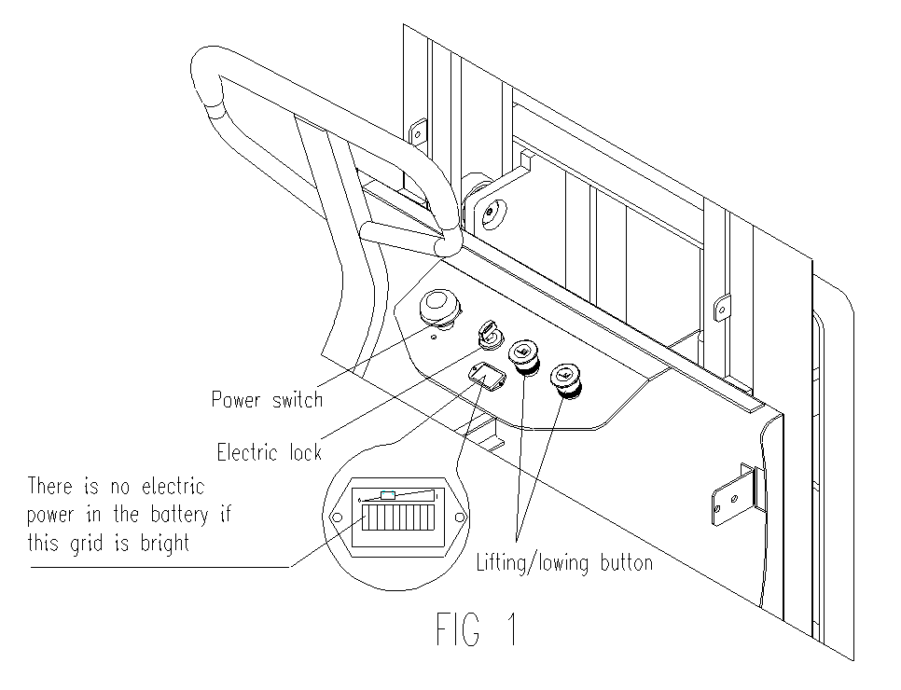
After the above check, if there is no failure in the stacker, it can be put into use; if there is some failure, please repair it at once. It is strictly prohibited to use faulty stackers.
5.2 In operation
5.2.1 Operation of handling and stacking:
Turn on the power switch, unlock the electric door lock, and drive the stacker to the goods pile nearby. (The tip of the fork is 300mm from the goods pile). Press the lowering button, adjust the height of the fork to a proper position, and insert the fork slowly and as deep as possible into the pallet of the goods. Press the lifting button till the fork is 200-300mm from the ground. Drive the stacker to the location of the goods shelf and stop slowly. (The tip of the fork is 300mm from the goods shelf. Press the lifting button and the fork rises to a proper height of the goods shelf (The bottom of the pallet is about 100mm higher than the goods shelf). Move the goods slowly to the accurate position of the shelf and press the lowering button to put the goods carefully on the shelf. Take the fork away from the goods and drive the stacker slowly to make the fork out of the goods pallet. (The tip of the fork is 300mm from the goods shelf.) Lower the fork until it is 300mm from the ground and drive the stacker away from the shelf.
5.2.2 Operation of taking goods off the goods shelves：
Pull out the general power supply switch to turn on the general power supply, unlock the electric door lock, and drive the stacker to the goods shelf nearby. (The tip of the fork is 300mm from the goods shelf). Press the lifting button, adjust the height of the fork to a proper position, and insert the fork slowly and as deep as possible into the goods pallet. Press the lifting button to lift the goods until the bottom of goods pallet is 100mm from the goods shelf, drive the stacker slowly until the goods is away from the goods shelf. (The tip of fork is 300mm from the goods shelf). Press the lowering button till the fork is 200-300mm from the ground. Drive the stacker away from the location of the goods shelf and stop slowly. Press the lowering button to put down the goods and make the fork away from the goods and drive the stacker slowly to make the fork out of the goods pallet.
- When the stacker is out of control, press the power switch immediately to cut off the general power supply.
- During lifting or lowering of the forks, do not push or pull the stacker, meanwhile don’t lift or lower the forks when the stacker is traveling.

- Maintenance and upkeep
6.1 Whether the stacker can operate satisfyingly depends on the efficient maintenance. When maintenance is ignored, the stacker may pose a threat to human lives and cause stacker and property damage. Routine inspection should be conducted, when the stacker is in operation, to eliminate abnormal conditions in time. Never use a stacker with malfunction to ensure safety and to prolong the service life of the stacker.
6.2 Maintenance：Maintenance of this stacker is generally divided into routine maintenance, periodic maintenances of the mechanical system , hydraulic system as well as the electric equipment.
Routine maintenance: Daily maintenance is to clean the surface of the stacker body and the surface of the storage battery; examine the firmness of the power supply cable.
a. Maintenance for mechanical system: Once half a year. The major content is to add lubricant to the bearings of wheels and mast. Meanwhile examine the firmness of the fixing fittings, the flexibility of the wheels and mast roller, as well as whether the forks can be lifted and lowered normally. The operation noise of the stacker shall not exceed 70 dB.
b. Maintenance for hydraulic system: Once every 6 months. Examine if the oil cylinder is normal, if there is any leakage externally or internally, if the hydraulic connection and the hose are reliable with no leakage. The hydraulic oil should be kept clean and generally it should be replaced every 12 months. ISO oil product standard is adopted for the hydraulic oil. When the ambient temperature is –5~ 40℃, HL-N46 or HL-N68 should be used; when the ambient temperature is –35~ –5℃, HV-N46 or HV-N68 should be used. The replaced waste oil should be treated according to the local rules and regulations.
c. Maintenance for electric equipment: Once every three months. First examine whether the specific gravity of the electrolytic solution of the storage battery [specific gravity at 1.24 (at 25℃) in tropical areas and 1.26 (at 25℃) in other areas] fits and the terminals are clean. Otherwise, the specific gravity of the electrolytic solution should be adjusted as required and the terminals should be cleaned and painted with Vaseline and tightened correctly. Examine if the connections of the electrical devices are reliable, the switches are normal and the insulation is ok (The insulating resistance between the electrical devices and the stacker body should be above 0.5MΩ).

- Common fault and trouble shooting
No. | Faults | Causes | Trouble shooting
1 | The forks cannot be lifted. | ① Overload | Reduce the load
 |  | ② The pressure of the overflow valve is too low. | Adjust the pressure higher
 |  | ③Internal abnormal leakage in the lifting oil cylinder | Replace the seals
 |  | ④Insufficient hydraulic oil | Add appropriate quantity of filtered hydraulic oil
 |  | ⑤ Insufficient voltage of the storage battery | Charge the battery
 |  | ⑥Main power switch is not open. | Open the main power switch.
 |  | ⑦The electric lock is not open or damaged. | Open the electric lock or repair it.
 |  | ⑧Damaged oil pump motor | Repair or replace
 |  | ⑨Damaged oil pump | Repair or replace
 |  | ⑩ Damaged lifting button | Repair or replace
2 | The forks cannot be lowered after lifted. | ①The internal mast is overloaded and deformed. | Repair or replace
 |  | ②The external mast is overloaded and deformed. | Repair or replace
 |  | ③ Frame roller is blocked. | Repair or adjust
 |  | ④Mast guiding rode is curved. | Repair or straighten
 |  | ⑤The oil return hole is blocked. | Clean
 |  | ⑥The electromagnetic valve of the hydraulic station is out of control. | Shoot the trouble
3 | Reduced voltage of the storage battery (after charging) | ① Damage of individual battery | Repair or replace
 |  | ② Low level of the electrolytic solution | Add electrolytic solution
 |  | ③ Foreign matters in the electrolytic solution | Replace electrolytic solution

- Use, maintenance and charging of the batteries
8.1 Initial charge
Note: The charging environment requires good ventilation and there should be no open flame, otherwise explosion may occur.
8.1.1 Initial charge should be conducted for new batteries. Before the initial charge, the surface of the batteries should be cleaned and the batteries should be examined for damage. The bolts should be tightened to ensure reliable connection.
8.1.2 Pull out the sealing cover and replace it with the open cover type liquid hole plug and open the cover.
8.1.3 When the charging equipment is able to operate normally, pour the sulfuric acid electrolyte with a density of 1.260±0.005 (25℃) and a temperature of lower than 30℃ into the batteries. The liquid surface should be 15-25mm higher than the protective board. In order to reduce the temperature rise caused by chemical reaction of the electrolyte and let the electrolyte fully penetrate into the pores of the polar plates and the baffles, the batteries should be placed still for 3-4 hours but not over 8 hours. The initial charging can only be conducted when the temperature of the solution drops to below 35℃. (When necessary, the batteries can be put into cold water for temperature reduction). After the still placement, if the surface of the electrolyte reduces, electrolyte should be added.
8.1.4 The sulfuric acid electrolyte is prepared with battery sulfuric acid complying with the state standard GB4554-84 and distilled water. Never use industrial sulfuric acid and running water. The standard temperature and density of the electrolyte can be converted as follows:
D25＝Dt＋0.0007(t－25)
Where: D25: the density of the electrolytic solution at 25℃
Dt: the actual density of the electrolytic solution at a temperature of t ℃.
t: temperature of the electrolytic solution when testing the density.
8.1.5 Sweep the electrolyte on the surface of the batteries and connect the positive and the negative poles of the battery pack respectively with the positive and the negative ends of the DC power supply (charger). Turn on the power supply. First charge with 18A (the first stage current); when the voltage reaches 14.4V (6 ×2.4V = 14.4V), change to the second stage current 9A and continue to charge. The temperature of electrolyte during the process of charging must not exceed 45℃ and when it is close to 45℃, the charging current should be reduced by 50% or the charging should be stopped temporarily. Wait till the temperature drops to 35℃ to continue the charging. The charging time, however, should be properly prolonged.
8.1.6 Fully charged basis: When the voltage during the second stage charging reaches 15.6V (6 ×2.6V = 15.6V), the variation of the voltage is no greater than 0.005 (V); the density of the electrolyte reaches 1.280 ±0.005 (25℃), no obvious variation in 2 hours and there are fine air bubbles appear violently, it can be deemed that the batteries are fully charged. The charged power capacity is 4-5 times of the rated capacity and the charging time is about 70 hours.
8.1.7 In order to accurately control the sulfuric acid content of the electrolyte, the electrolyte density of the batteries should be examined during the last period of charging. If there is inconsistence, adjust with distilled water or sulfuric acid with a density of 1.40. The electrolyte density and the liquid surface should be adjusted to the stipulated value within two hours in the charging state.
8.1.8 After the initial charging is completed, the surface of the batteries should be cleaned. Close the cover of the open cover type liquid hole plug and then the batteries can be used.
8.2 Use and maintenance
8.2.1 In order to guarantee the service life of the batteries, the batteries in use should be fully charged. Insufficiently charged batteries must not be used. During the process of use, close attention should be paid to the discharge extent. Over discharge is prohibited---the voltage reduces to 1.7V per battery (when the total voltage reduces to 1.7V×6 = 10.2V ). When the density of the electrolyte reduces to 1.17, discharging should be stopped and charging should be conducted at once. The batteries should not be placed idle for a long period of time. The supplementary charging frequently conducted during the process of use is called common charge.
8.2.2 Common charge: The first stage current of common charge is 26A and that of the second stage is 13A. The charging method is the same as that of initial charge. The charged volume is 130-140 % of the discharged volume and the charging time is about 15 hours.
8.2.3 The batteries in normal use should avoid over-charge, but over-charge must be properly conducted for the batteries in the following situation, i.e. equalizing charge.
a. The “lag-behind” batteries--- batteries with a voltage lower than that of the other batteries in the charging and discharging process and the batteries having been repaired for failure. (When equalizing charge is conducted, the positive and negative poles of the “lag-behind” battery should be respectively connected with the positive and negative ends of the DC power supply, and the charge should be conducted independently.)
b. Equalizing charge should be conducted for the batteries in normal use every 2-3 months.
c. Equalizing charge should be conducted for the batteries that have not been used for a long period of time before use.
8.2.4 Equalizing charge:
a. Charge with a 4A current
b. When the charge voltage reaches 15.6V (6 ×2.6V = 15.6V) and air bubbles occur in the electrolyte, the current should be reduced by 50% (2A) and continue to charge.
c. When the batteries are fully charged, stop charging for 0.5 hour and charge again with a 1A current for one more hour.
d. Stop charging for another 0.5 hour and charge with a 1A current for another one hour.
e. Repeat according to item d till air bubbles occur violently in the batteries once the charger is switched on.
8.3 Storage
8.3.1 Batteries should be stored in a clean, dry and well-ventilated warehouse with a temperature of 5-40℃. The valid storage life is 2 years. The batteries should be kept according to the following requirements during storage period:
a. No direct sunlight on the batteries and at least 2m away from heat source.
b. Avoid contacting with any harmful substances. No metallic matters are allowed to drop into the batteries.
c. The batteries should not be placed upside down and should not be hit mechanically or heavily pressed.
e. The batteries must not be stored with electrolytic solution. When it is required in special situation that the batteries must be stored with electrolytic solution, the batteries should be fully charged and the density and the liquid surface of the batteries should be adjusted to the stipulated values. When the storage period comes to one month, the batteries should be complementarily charged with the common charge method.
- Lists of accessories, spare parts and vulnerable parts
No. | Name | Use position | Type & specification | Quantity | Remarks
1 | Key to the electric lock | Electric lock |  | 2
2 | Charging plug and socket | Matched with the charger |  | 1 set
3 | Fuse | Electric equipment | 10A | 1
4 | Fuse | Electric equipment | 160A | 1
5 | Sealing ring | Oil cylinder | UHS40 | 1
6 | O–ring | Oil cylinder | 50×3.55 | 1
7 | O–ring | Oil cylinder | 23.6×3.55 | 1
8 | Composite ring | Oil inlet of cylinder | d14 | 1
9 | Dustproof ring | Oil cylinder | DH40 | 1
- Package & transportation
The stacker is packed with a pallet. During transportation, turnover and upside-down are not allowed. Collision is not allowed when lifting and loading onto the truck. Do not damage the outward surface of the stacker when the package is unwrapped.

- Warning (points for attention)
11.1 Read the manual carefully before operation so as to know the performances of the stacker.
11.2 It is strictly forbidden to press and frequently switch the lifting and lowering buttons while the stacker is traveling. Otherwise, it might damage the stacker and the goods.
11.3 It is not allowed to rapidly put heavy goods onto the forks.
11.4 The stacker should not be overloaded. When overloaded, the stacker will not be able to operate normally.
11.5 The center of gravity of the goods should be placed between the two forks, otherwise, the forks will be damaged and the goods will fall down in the process of operation.
11.6 Loose and unstable goods are not allowed to load onto the stacker.
11.7 Do not put the goods on the forks for a long period of time.
11.8 When the stacker is not in use, the forks should be lowered to the lowest position.
11.9 Never put any part of human body under heavy goods and forks.
11.10 The stacker is applicable for use on flat ground and should never be parked on slope for a long period of time.
11.11 It is strictly forbidden to lift goods under the stipulated voltage 10.2V, otherwise it cause damage to the battery.
11.12 It is strictly forbidden to directly connect the plug with AC power supply for charge.
11.13 The operator must put on the safety cap during operation of the stacker.
11.14 When the lift height of forks exceeds 500mm, the stacker must travel at the minimum speed and the continual traveling distance must not exceed 2m.

- Structure diagram and principle diagram of the major parts

Hydraulic Principle Diagram

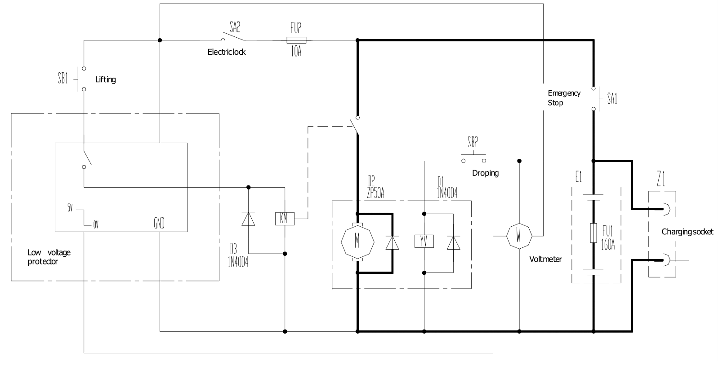

Electric Schematic Diagram
- Packing list

Packing List of CDDB-Ⅲ、CTDB-Ⅲ Semi-Electric Stacker

Consignee: Ex-factory No.:
Contract No.: Ex-factory Date:
No. | Name | Quantity | Net weight | Dimension  (L×W×H) | Remarks
1 | CDDB-Ⅲ、CTDB-Ⅲ Semi–electric stacker | 1 |  |  | A complete set.
2 | Accessory box | 1 |  |  | Technical documents, accessories and spare parts.
Note: 1. The following documents are in the file bag:
① Operation manual of CDDB-Ⅲ、CTDB-Ⅲ Semi-electric Stacker 1 volume
② Packing list 1 copy
③ Qualification certificate 1 copy
2．Accessories and spare parts
No. | Name | Use position | Type & specification | Quantity | Remarks
1 | Key to electric lock | Unlock the electric lock |  | 2
2 | Charging plug and socket | Matched with the charger |  | 1 set
3 | Fuse | Electric equipment | 10A | 1
4 | Fuse | Electric equipment | 160A | 1
5 | Sealing ring | Oil cylinder | UHS40 | 1
6 | O–ring | Oil cylinder | 50×3.55 | 1
7 | O–ring | Oil cylinder | 23.6×3.55 | 1
8 | Composite ring | Oil inlet of cylinder | d14 | 1
9 | Dustproof ring | Oil cylinder | DH40 | 1
Consigner:

